UNIVERSITY OF INFORMATION TECHNOLOGY  COMPUTER ENGINEERING DEPARTMENT | FINAL EXAMINATION II (2018-2019)  COURSE: DEGITAL LOGIC DESIGN  Time duration: 90 minutes  (Paper materials are allowed)
STUDENT NAME: ……………………………………ID: …………..ORDER:…

Question 1 (3 points)
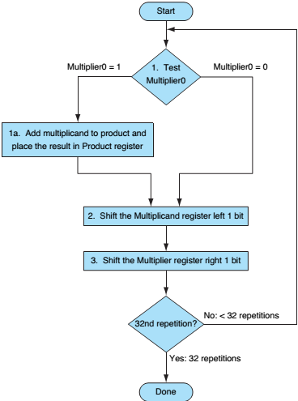
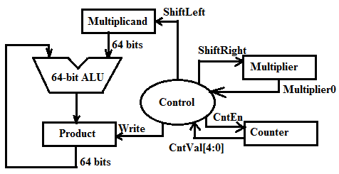
Figure 1: Multiplication circuit

Based on Multiplication circuit and its ASM on
Figure 1 and Figure 2, please derive the Moore-
FSM to design the Control module for Multiplication
circuit. Figure 1: Multiplication ASM

Question 2 (3 points)
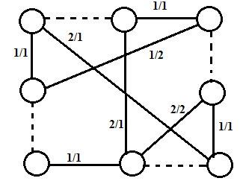
Group the nodes specified by the compatibility graphs
showed in Figure 3.

Figure 3: Compatibility graph

Question 3 (4 points)
Construct a pipelined data-path for the Square-Root Approximation (SRA) circuit by dividing an SRA algorithm into three stages as Figure 4. Then, derive its timing diagram.
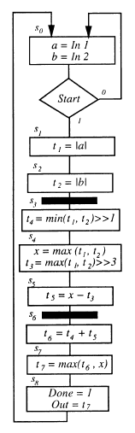
Figure 4: ASM for three-stages SRA
This examination’s learning outcomes (LO) (matching to subject syllabus’s LO)
Question | LO | Description
1 | G1 | Be able to design the controller
2 | G2 | Be able to optimize the design
3 | G3 | Be able to design and analyze digital circuit

Approved by Head of Subject Designed by
Lâm Đức Khải Lâm Đức Khải

